**Bonus Assignment**

**Submission deadline Friday December 9, 2022 @ 11:59 PM**

**(ONLY Google Classroom SUBMISSIONS ALLOWED) (NO EMAIL SUBMISSIONS) (NO DEADLINE EXTENSIONS)**

**Question # 1:**

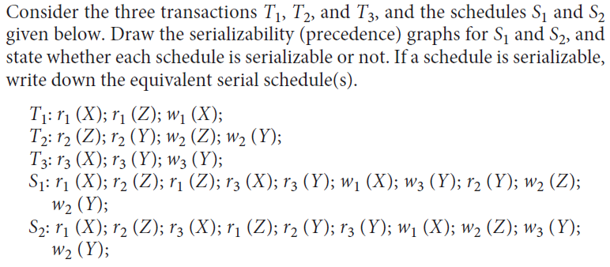

**Question 2:** List all possible schedule for transactions T1 and T2 given below, and determine which are conflict serializable (correct) and which are not.

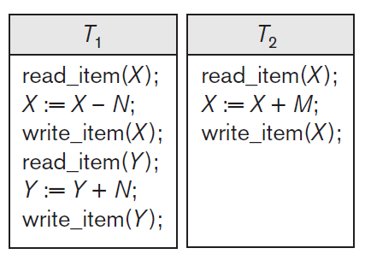

The transactions given above can be written as follows using shorthand notation:

T 1 : r 1 (X); w 1 (X); r 1 (Y); w 1 (Y);

T 2 : r 2 (X); w 2 (X);

HINT:

In this case:

m = 2, (total number of transactions), and

n1 = 4, (number of operations in transaction 1), and

n2 = 2, (number of operations in transaction 2).

The generic formula for calculating the total number of schedules is: (n1+n2)! / (n1! * n2!)

So, the total number of possible schedules in this case will be:

(4+2)! / (4! * 2!) = 6*5*4*3*2*1/ 4*3*2*1*2*1 = **15**